# DAY 4 Lab Programs

1. **1. Counting Elements Given an integer array arr, count how many elements x there are, such that x + 1 is also in arr. If there are duplicates in arr, count them separately.**

Code:-

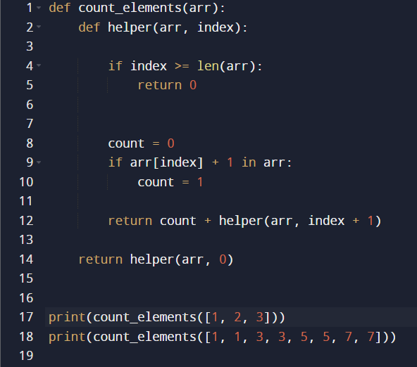

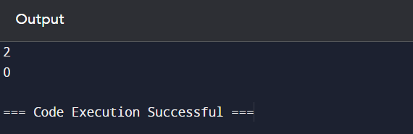

* Time Complexity of the above code is *O*(*n*).

1. Perform String Shifts

Code:-

